Compensation Scheme for PDR using Sparse Location and Error Model

Nobuo Kawaguchi

Institutes of Innovation for Future Society, Nagoya University, Japan

kawaguti@nagoya-u.jp

Junto Nozaki

Graduate School of Engineering, Nagoya University, Japan

nozaki@ucl.nuee.nagoya-u.ac.jp

Kei Hiroi

Institutes of Innovation for Future Society, Nagoya University, Japan

k.hiroi@ucl.nuee.nagoya-u.ac.jp

Katsuhiko Kaji

Faculty of Information Science, Aichi Institute of Technology, Japan

kaji@aitech.ac.jp

Permission to make digital or hard copies of all or part of this work for personal or classroom use is granted without fee provided that copies are not made or distributed for profit or commercial advantage and that copies bear this notice and the full citation on the first page. Copyrights for components of this work owned by others than the author(s) must be honored. Abstracting with credit is permitted. To copy otherwise, or republish, to post on servers or to redistribute to lists, requires prior specific permission and/or a fee. Request permissions from Permissions@acm.org.  
  
*UbiComp/ISWC'17 Adjunct ,* September 11–15, 2017, Maui, HI, USA  
© 2017 Copyright is held by the owner/author(s). Publication rights licensed to ACM.  
ACM 978-1-4503-5190-4/17/09…$15.00   
https://doi.org/10.1145/3123024.3124406

# Abstract

One of the indoor localization methods utilizing accelerometer and gyroscope is called PDR (Pedestrian Dead Reckoning). Various schemes have been proposed in PDR, however, sufficient precision has not been achieved because of the error accumulation. In this research, we propose a PDR error compensation scheme based on an assumption that can obtain sparse locations. Sparse locations mean discontinuous locations obtained by using absolute localization method or passage detection devices (ex. BLE, Magnetic Field). We attempt to compensate the trajectory of PDR estimation and improve estimation precision by sparse locations. Then we tune parameters describing errors. In our scheme, we define error models that represent errors in PDR, including moving distance error and orientation changing error. Moreover, we define parameters to describe these errors. As a result, proposed scheme improved position error rate approximately10% and route distance error rate approximately 7%.

# Author Keywords

Pedestrian Dead Reckoning; Compensation; Smartphone; Sensor; BLE;

# ACM Classification Keywords

H.1.2 [User/Machine Systems]: Human information processing.

# Introduction

Existing indoor localization methods, there are absolute localizations and relative localizations. Absolute localization methods utilize such as Wi-Fi access points [8] or BLE (Bluetooth Low Energy) beacons [6]. These types of methods must install additional devices. Moreover, many methods use fingerprinting, these measurement cost are high. Reducing the cost, the method called SLAM (Simultaneously Localization and Mapping [3] is proposed. However, updating cost has yet been high. One relative localization method utilizes accelerometer and gyroscope is called PDR. Because this method incrementally estimates the user’s current relative position, estimation error accumulates with the passage of time. PDR estimation contains some kinds of error. For example, inaccurate step length calculated from stature causes moving distance error, and drift of gyroscope causes orientation error. To compensate these errors, a scheme utilizing map matching [11] has been proposed. However analyzing these errors is insufficient.

In this research, we suppose the situation that can obtain sparse locations. Sparse locations mean discontinuous locations obtained by absolute localization such as passage detection [12] at some points, for example, the four corners of an area. In the real world, it is difficult to obtain absolute locations continuously at the indoor environment. Therefore, we utilize locations to compensate localization errors. Sparse locations do not require fingerprint of signal strength, therefore, our scheme is costless. Moreover, because the passage detector can be deployed in a broad area where map matching is difficult to use, our scheme using sparse locations can compensate estimation robustly.

To compensate errors, we consider the cause of errors. Then defined the error model of moving distance, orientation changing and drift angle. We compensate estimation trajectory and update parameters describing error models every each obtaining sparse location. Utilizing updated error models, we compensate estimation point by point to improve the precision.

# Related Work

Various PDR schemes are proposed to improve precision. For example, a scheme utilizes accelerometer, gyroscope, and magnetometer [5], or utilizes pressure sensor to extend estimation in multi-floor [7][9]. However, these estimation schemes accumulate error, but cannot remove accumulation error. Therefore there is a problem that these schemes are difficult to use for a long time.

For this reason, some schemes that are combined with other localization methods are proposed. For example, a scheme combines PDR with Wi-Fi fingerprint [4] or magnetic field fingerprint [2]. These schemes estimate location by combining information of Wi-Fi signal strengths or magnetic sensor values with moving distances and orientation changings estimated by PDR. However, these schemes require collecting environmental information and creating a fingerprint of a map in advance. When we collect environmental information, the whole area should be collected. Therefore the measurement, maintenance and updating cost are high.

As other approaches, some methods have been proposed to improve precision. For example, a scheme that adjusts user’s step length utilizing GPS [10] or compensates estimation using map-matching utilizing building structure information. The former scheme calculates the step length from step counts obtained by step detection utilizing accelerometer and moving distance obtained from the GPS. This scheme can reduce the error of moving distance. However, because it requires a calibration walking outdoor before indoor localization, it is difficult to use. The latter scheme compensates user’s step length and orientation changing utilizing turn detection and corner information of a map. However, requiring turn information at corners, it is difficult to use in a broad area such as an airport lobby. In the previous research, the situations that can compensate estimation are limited. Suppose estimation compensation is able to execute robustly and costless, more practical indoor localization is implemented.

# Proposal of Compensation Scheme

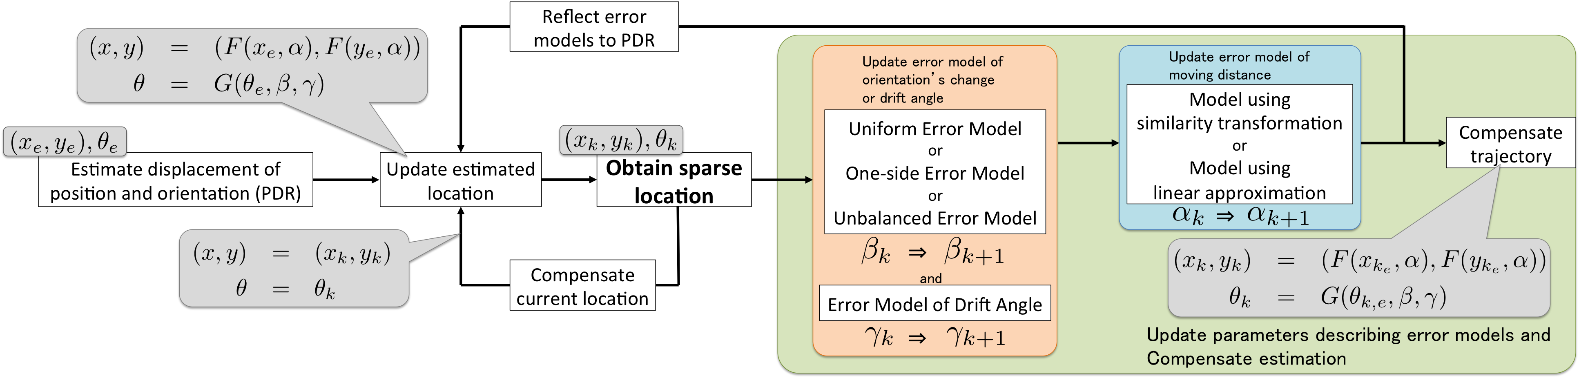

Figure 1. System flow of proposed scheme.

|  |  |
| --- | --- |
| Symbol | Explanation |
|  | The time obtainedsparse location |
|  | The coordinate ofsparse location |
|  | The coordinate of estimated location whensparse location is obtained |
|  | The coordinate of estimated location when compensation is not used |
|  | The error distance when compensation is not used |
|  | , the time fromsparse location toone |
|  | A coordinate of estimated location |
|  | A coordinate of compensated location |
|  | The parameter describing error modelof moving distance |

Table 1. Symbols and its explanation using in the section “Error Model of Moving Distance”.

In this research, we focus on sparse locations, for example, the location that is obtained by passage detection. We compensate PDR estimation utilizing sparse locations. We utilize this because we consider obtaining high precision locations in some specific points is preferable than obtaining locations moderately in a whole area. Also, because passage detectors can be deployed optional location in a broad area, utilizing sparse locations allow us to reduce restriction.

In proposed scheme, we define error models of moving distance, orientation changing and drift angle. Parameters describing these error models are updated every time measuring a sparse location, and then they are utilized in PDR estimation. Figure 1 shows the whole system of proposed scheme. As shown in Figure 1, our scheme compensates moving distance error after compensates orientation change error. Because the compensation of moving distance error uses the distance between a location estimated by PDR and a sparse location. This distance is changed by orientation change error compensation.

## Error Model of Moving Distance

In this research, we propose two moving distance error models. One uses a relationship between moving distance and moving distance error, and the other uses a relationship between elapsed time and moving distance error. A parameter describing the former is moving distance error generated per meter, and another parameter describing the latter is moving distance error generated per second. The description of symbols using in this section is summarized in Table 1.

### Model using Similarity Transformation

This model based on the idea that moving distance error accumulates proportionally to moving distance from the initial location. The distance from a previous sparse location to a new one is exactly same to user’s moving distance. Therefore compensate to be equal to using similarity transformation. First, we calculate the scale factor . Then, update the parameter describing this model by the following equations.



|  |  |
| --- | --- |
|  | (1) |
|  | (2) |

The initial value of is 1. represents slope which sets moving distance on a horizontal axis and moving distance error on a vertical axis. As shown in Figure 2, this parameter describes this similarity transformation model. Using this model, we apply compensation to PDR estimation. The estimated location after the time  from the previous sparse location is compensated to by the following equation.



|  |  |
| --- | --- |
|  | (3) |

### Model using Linear Approximation

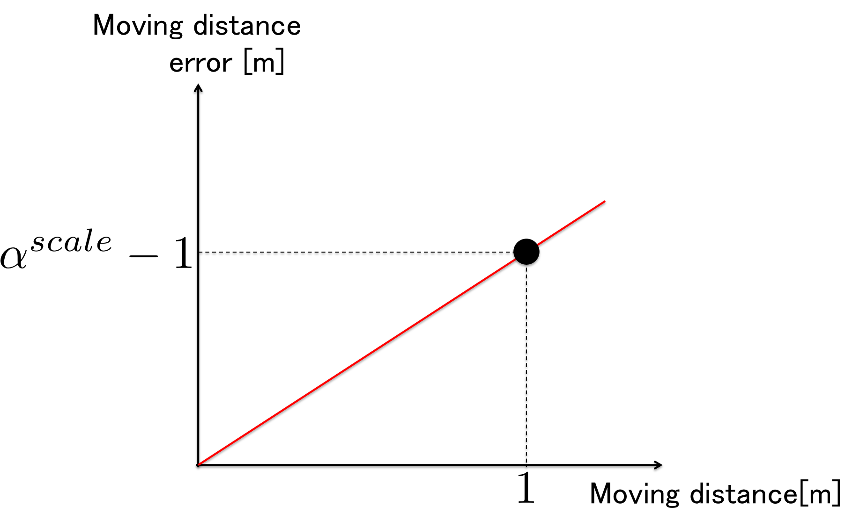

Figure 2. Form of the model using similarity transformation.

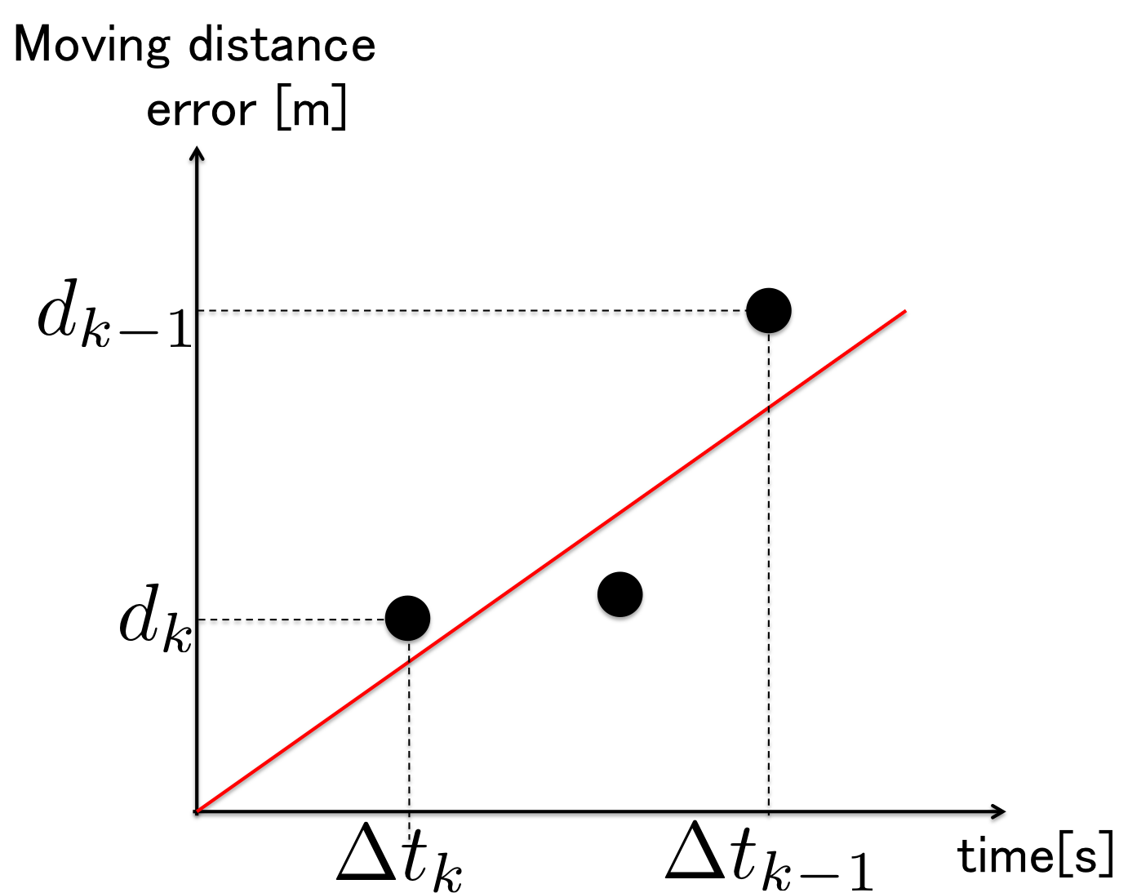

Figure 3. Form of the model using linear approximation.

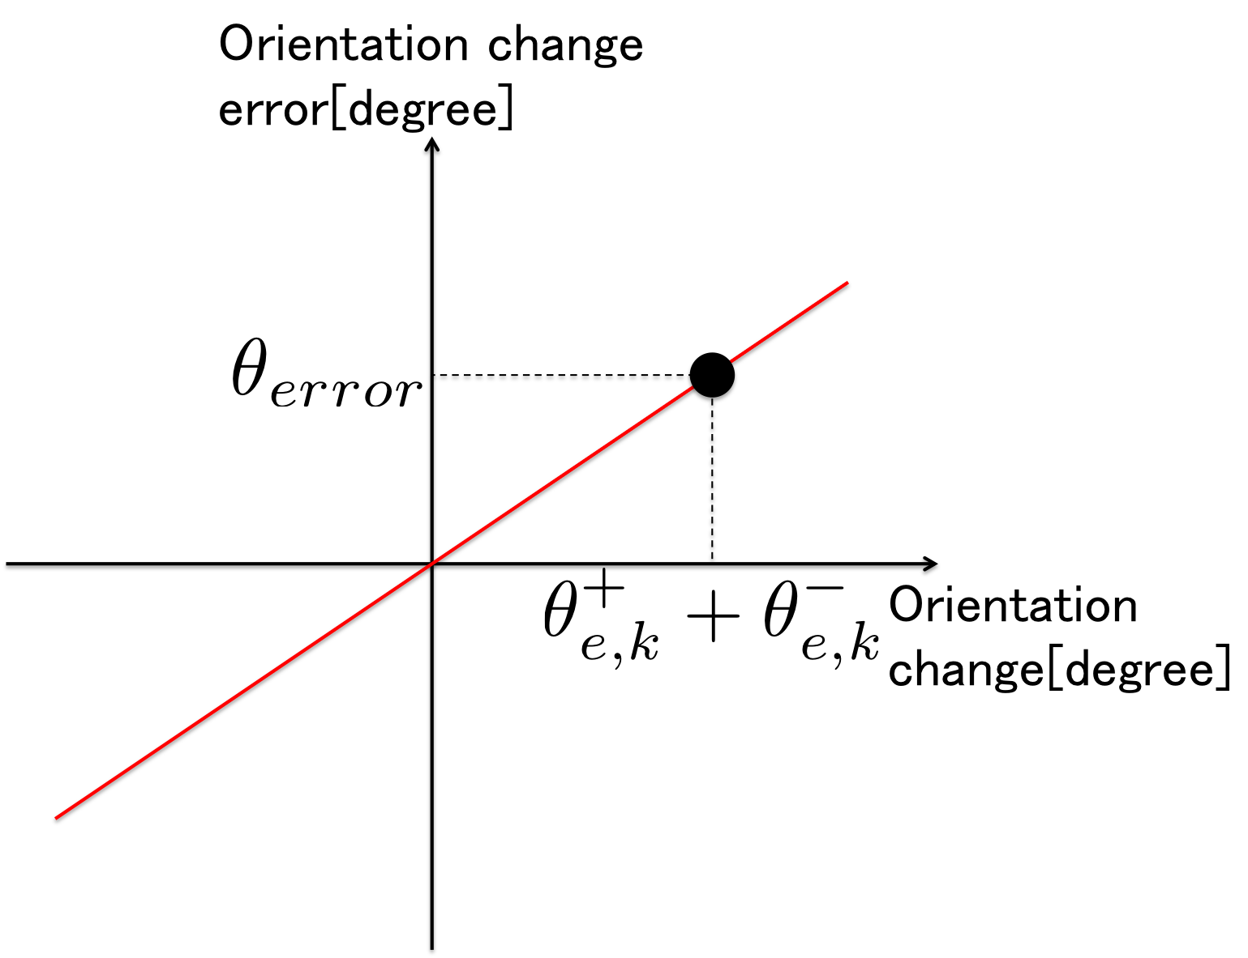

Figure 4. Form of uniform error model.

This model based on the idea that moving distance error accumulates proportionally to the elapsed time. The parameter describing this model is updated by applying the linear approximation to sets of a elapsed time and a moving distance error. First, we calculate the moving distance error using : the coordinate estimated by PDR that do not compensate estimation by utilizing error model. At this time, hold and moving time . Then, update the parameter describing this model by the following equations.



|  |  |
| --- | --- |
|  | (4) |
|  | (5) |

represents slope which sets moving time on a horizontal axis and moving distance error on a vertical axis. As shown in Figure 3, this parameter describes this linear approximation model. Using this model, we apply compensation to PDR estimation. The estimated location after the time from the previous sparse location is compensated to by the following equations.



|  |  |
| --- | --- |
|  | (6) |
|  | (7) |

## Error Model of Orientation Changing

In this research, we propose three patterns of orientation change error model that use a relationship between orientation change and orientation change error. The parameter, which describes these models, is orientation change error generated per degree. We designed three patterns of the model because we consider that it is possible that orientation change error may occur at different rates when people turn left or turn right. The description of symbols using in this section is summarized in Table 2.

### How to Calculate Orientation changing

For example in the case that the orientation of sparse location is equal to one of , the value of cannot be determined uniquely but can take . Therefore, we calculate as follows. First, we calculate orientation change error by the following equation.

|  |  |
| --- | --- |
| Symbol | Explanation |
|  | The time obtainedsparse location |
|  | The orientation changing fromsparse location toone |
|  | The accumulation of estimated positive or negative orientation changing |
|  | The amount of updating parameter |
|  | An estimated orientation changing |
|  | A compensated orientation changing |
|  | The parameter describing error model of orientation |
|  | The parameter describing error model of drift angle |

Table 2. Symbols and its explanation using in the section “Error Model of Orientation Changing” and “Error Model of Drift Angle”.



|  |  |
| --- | --- |
|  | (8) |

The initial value of is 0. Second, suppose the error of orientation change is in the range , calculate by the following equation.



|  |  |
| --- | --- |
|  | (9) |

Finally, execute the operation of equation (7) and (8) recursively until is in the range .



### (1) Uniform Error Model

This model based on the idea that each orientation change error may occur at uniformly. First, we calculate : the ratio of orientation change error to orientation change. Then, update which is the parameter describing this model by the following equations.



|  |  |
| --- | --- |
|  | (10) |
|  | (11) |

The initial value of is 0. represents slope which sets orientation change on a horizontal axis and orientation change error on a vertical axis. As shown in Figure 4, this parameter describes this uniform error model. Using this model, we apply compensation to PDR estimation. The estimated orientation change from the previous sparse location is compensated to by the following equation.



|  |  |
| --- | --- |
|  | (12) |

### (2) One-side Error Model

This model based on the idea that all the orientation change errors may occur at the one-sided, which positive or negative. First, we calculate the ratio of orientation change error to positive or negative direction orientation change and . Then, update and which are the parameters describing this model by the following equations.



|  |  |
| --- | --- |
|  | (13) |
|  | (14) |

The initial value of and are both 0. and represent slopes which set orientation change on a horizontal axis and orientation change error on a vertical axis. As shown in Figure 5, this parameter describes this one-side error model. Using this model, we apply compensation to PDR estimation. The estimated orientation change from the previous sparse location is compensated to by the following equation.



|  |  |
| --- | --- |
|  | (15) |

### (3) Unbalanced Error Model

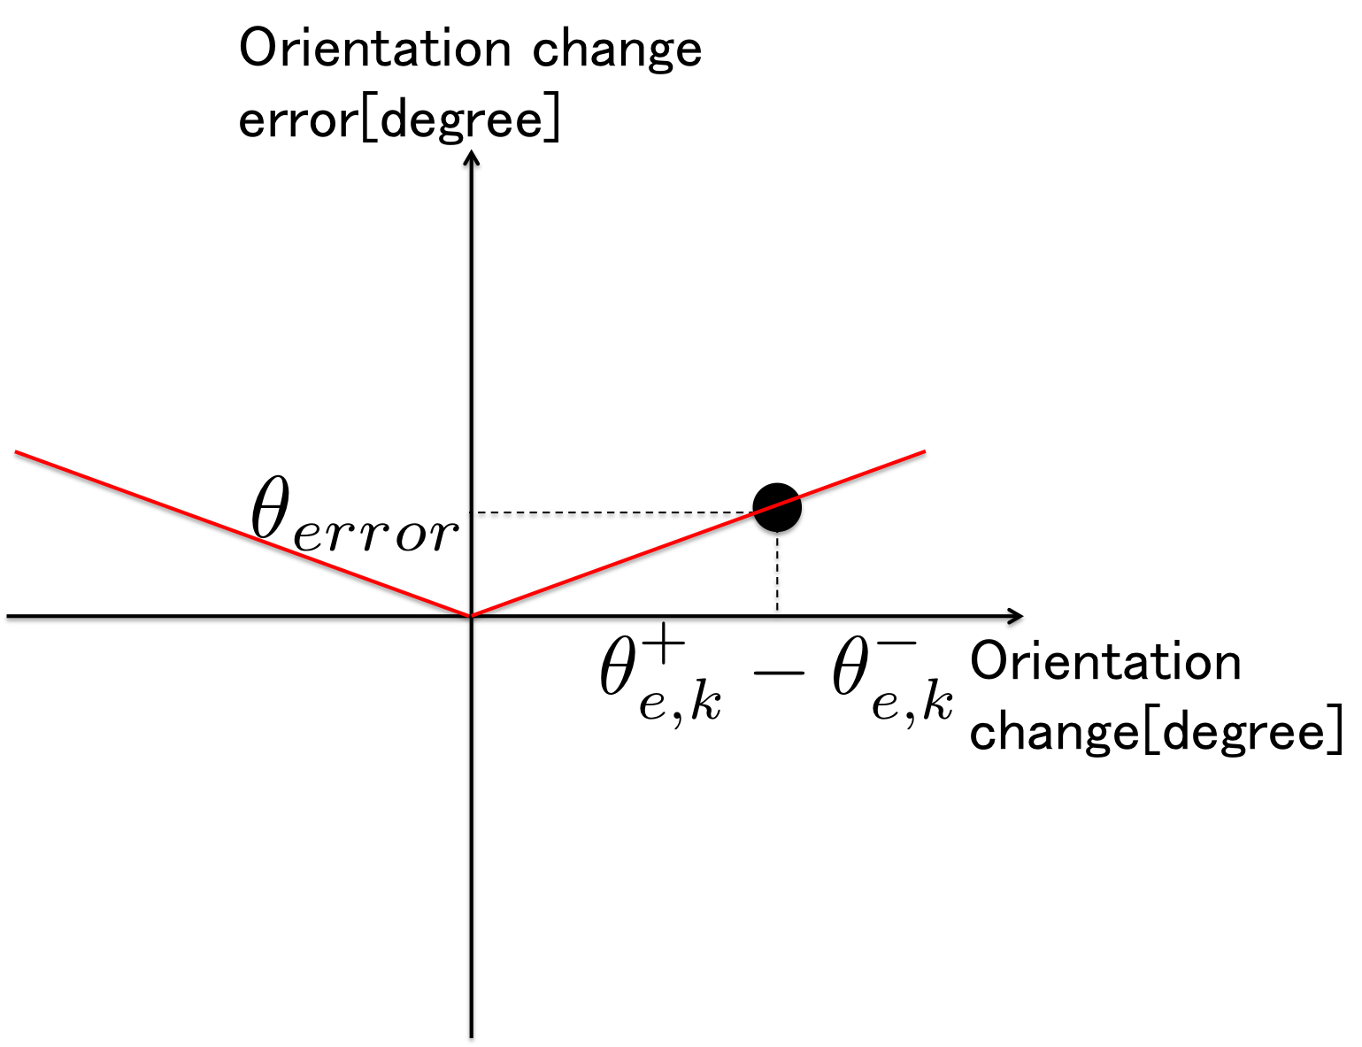

Figure 5. Form of one-side error model.

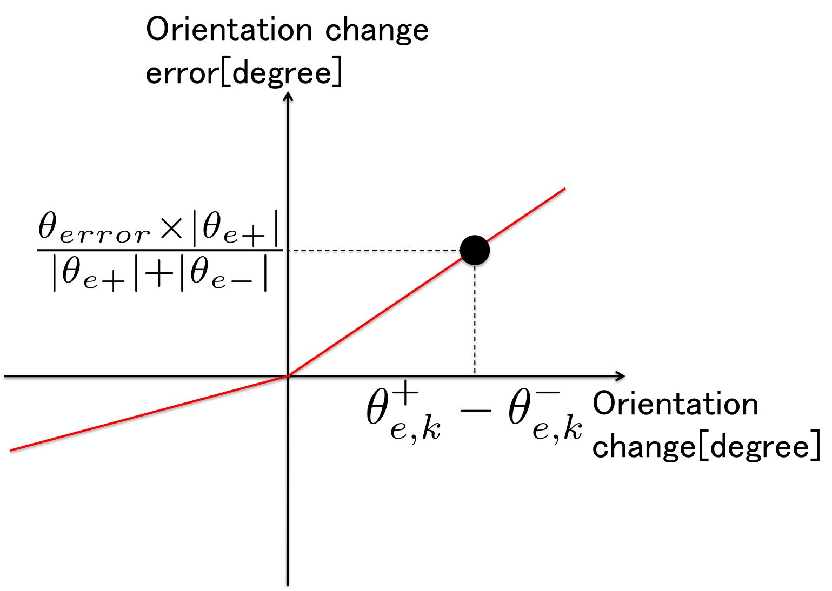

Figure 6. Form of unbalanced error model.

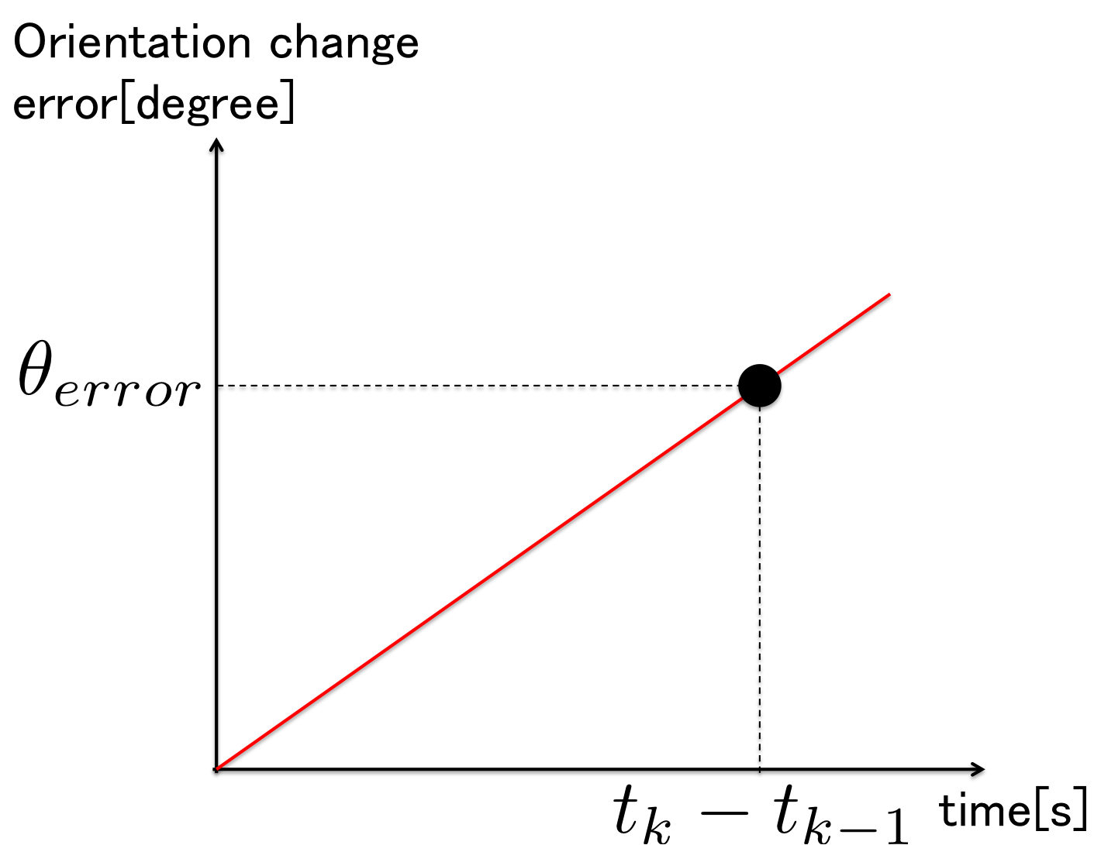

Figure 7. Form of drift angle error model.

This model based on the idea that orientation change errors may occur at different rates in positive or negative direction orientation change. First, we calculate the ratio of orientation change error to positive or negative direction orientation change and by the equation (16). Then, update and which are the parameters describing this model in the same way to equation (14).



|  |  |
| --- | --- |
|  | (16) |

The initial value of and are both 0. and represent slopes which set orientation change on a horizontal axis and orientation change error on a vertical axis. As shown in Figure 6, this parameter describes this unbalanced error model. Using this model, we apply compensation to PDR estimation. The estimated orientation change after the time from the previous sparse location is compensated to the in the same way to equation (15).



## Error Model of Drift Angle

The parameter describing this model is orientation change error generated per second. In the case of calculated in the Section “How to Calculate Orientation Changing” is 0, update this model. First, we calculate which is the ratio of orientation changing error to elapsed time . Then, update  which is the parameter describing this model by the following equations.



|  |  |
| --- | --- |
|  | (17) |
|  | (18) |

The initial value of is 0. represents slope which sets elapsed time on a horizontal axis and orientation change error on a vertical axis. As shown in Figure 7, this parameter describes this drift angle error model. Using this model, we apply compensation to PDR estimation. The estimated orientation change after the time from the previous sparse location is compensated to by the following equation.



|  |  |
| --- | --- |
|  | (19) |

# Evaluation

For evaluating our proposed scheme, we collected pedestrian walking data from Geospatial EXPO 2016[1] held at National Museum of Emerging Science and Innovation. We set the situation that can obtain sparse locations around the four corners. As the sparse location, we utilize the location obtained from UWB (Ultra Wide Band) localization system, which needs dedicated devices. However, we can obtain sparse locations, which contain error approximately 15-30cm. Moreover, we also utilize the location obtained from UWB localization system as correct location to evaluate proposed scheme.

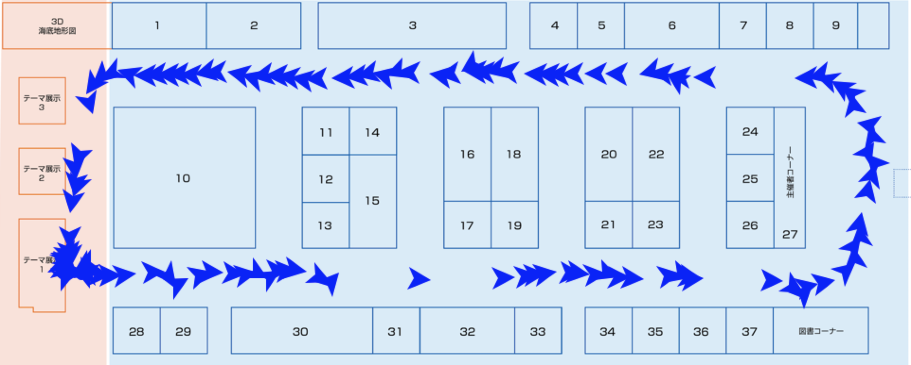

(a) Route A

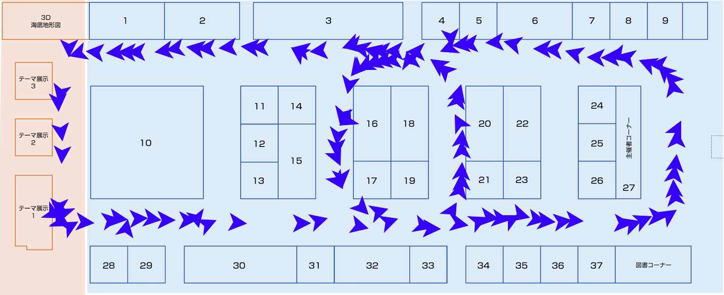

(b) Route B

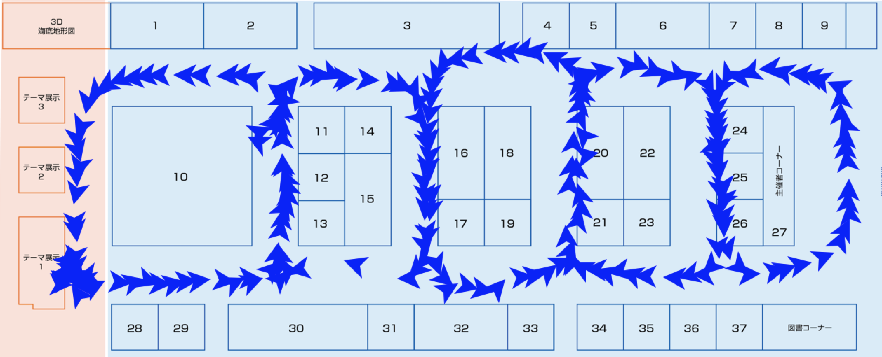

(c) Route C

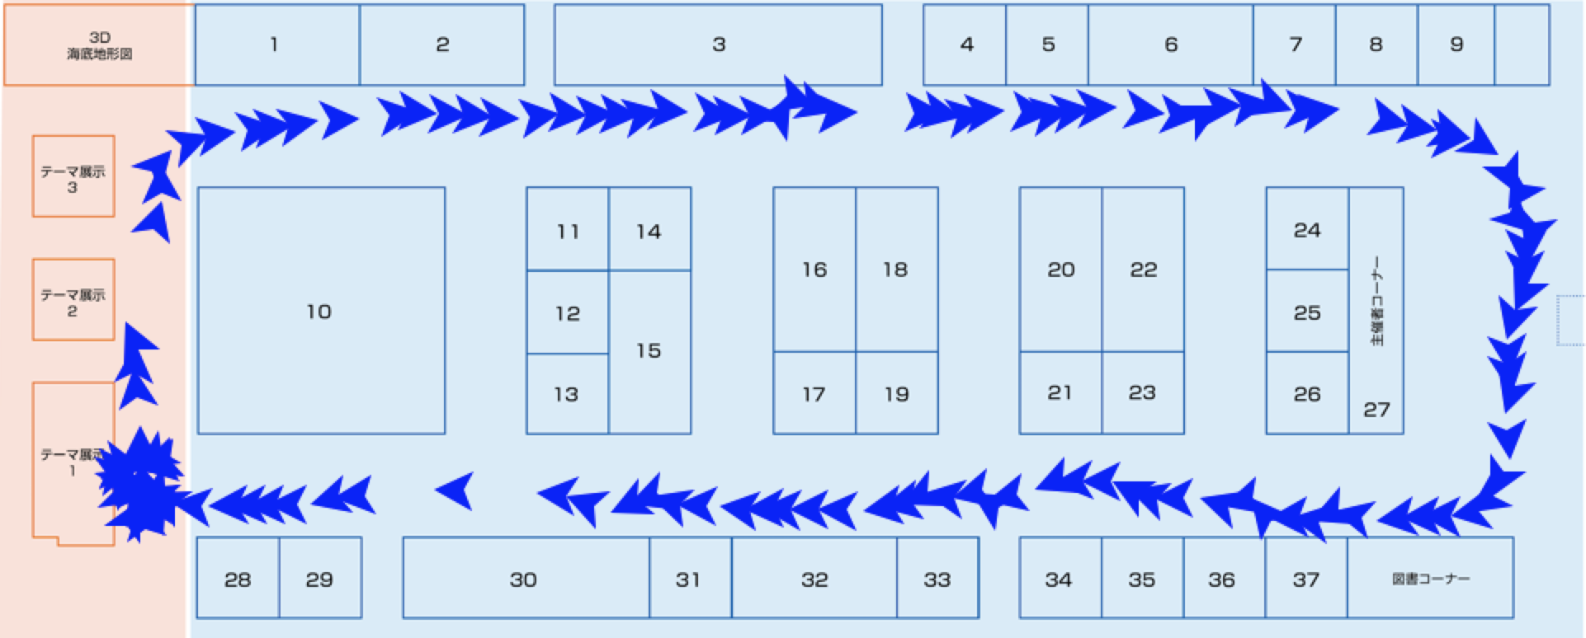

(d) Route D

Figure 8. The shape of routes.

Table 3, Table 4 and Figure 8 show the information of collected data and used routes. In proposed scheme, the parameters describing error models are updated every time measuring sparse location as mentioned in the section “Proposal of Compensation scheme”. Moreover, the previous estimated trajectory is compensated at the same time. This trajectory compensation is useful for the purpose of people flow analysis. However trajectory compensation is meaningless for the purpose of navigation, real-time estimation is important for this purpose. Therefore, we evaluate post compensation, which executes the previous trajectory compensation, and real-time compensation, which does not execute this.

We use following things as evaluation metric based on the reference [1].

* Position error rate, which is generated per second
* Route distance error rate, which is generated per meter

The Unit of these metrics is a percentage. However, they stand for  or . Metrics are derived as follows. First, we calculate each error every correct location obtained by UWB localization system. Second, we create scatter plot that set time or distance on a horizontal axis and error on a vertical axis by putting all the calculated errors. Third, we calculate the slope of the line regressed by using the least square estimation method. This slope is evaluation metric. Finally, calculate the average of four route’s evaluation location estimation error. Table 5 shows the average of evaluation location estimation error for each second or meter without compensation.

## Post compensation

Table 6 shows the average of evaluation location estimation error. In post compensation, the position error rate is improved to approximately 10% when utilizing the similarity transformation model. Moreover, route distance error rate is improved to approximately 7% when utilizing the linear approximation model.

## Real-time compensation

Table 7 shows the average of evaluation location estimation error. In real-time compensation, utilizing the linear approximation model tends to be fine rather than utilizing the similarity transformation model. Both evaluation metric values decrease approximately 3% lower.

## Discussion about Error Model of Moving Distance

In post compensation, from the viewpoint of position error rate, utilizing the similarity transformation model tends to be fine rather than utilizing the linear approximation model. The best error rate when utilizing similarity transformation model is 10.37% and the best error rate when utilizing the other model is 13.49%. From the viewpoint of route distance error rate, it is the opposite. The best error rate when utilizing the similarity transformation model is 7.70%, and when utilizing the other, it is 6.40%. It is because that the similarity transformation model compensates the estimation at the time when obtaining a sparse location so that it coincides the sparse location. Therefore improve position error rate. Conversely, the linear approximation model, which uses the error distance per second, is reflected in the estimation of moving velocity. Therefore it decreases route distance error rate.

In real-time compensation, both metrics tend to be fine when utilizes the linear approximation model. The best position error rate is 24.94% and distance error rate is 11.42%. Currently, the similarity transformation model uses the newest sparse location only when updates the parameter describing this model. Therefore there is possible that the parameter describing this model is changed largely every time updating this model.

|  |  |  |  |  |
| --- | --- | --- | --- | --- |
| Orientation error model | Without Model | Model (1) | Model (2) | Model (3) |
| Position | 17.19% | 11.78% | 10.37% | 10.85% |
| Distance | 16.50% | 7.70% | 7.96% | 8.65% |

(a) Utilize the model using similarity transformation.

|  |  |  |  |  |
| --- | --- | --- | --- | --- |
| Orientation error model | Without Model | Model (1) | Model (2) | Model (3) |
| Position | 17.01% | 15.53% | 14.63% | 13.49% |
| Distance | 6.40% | 7.21% | 7.24% | 7.01% |

(b) Utilize the model using linear approximation.

Table 6. Evaluation location estimation error average of post compensation.

|  |  |  |  |  |
| --- | --- | --- | --- | --- |
| Orientation error model | Without Model | Model (1) | Model (2) | Model (3) |
| Position | 27.43% | 28.65% | 31.35% | 29.47% |
| Distance | 13.94% | 15.33% | 14.36% | 15.09% |

(a) Utilize the model using similarity transformation.

|  |  |  |  |  |
| --- | --- | --- | --- | --- |
| Orientation error model | Without Model | Model (1) | Model (2) | Model (3) |
| Position | 25.19% | 24.94% | 28.14% | 26.55% |
| Distance | 11.42% | 11.70% | 11.42% | 11.61% |

(b) Utilize the model using linear approximation.

Table 7. Evaluation location estimation error average of real-time compensation.

## Discussion about Error Model of Orientation

|  |  |
| --- | --- |
| Number of subjects | 2 |
| Number of routes | 4 |
| Place of smartphone | Waist |
| Size of the area | 23mx70m |

Table 3. Experiment information.

|  |  |  |
| --- | --- | --- |
|  | Length | Corner |
| A | 120 | 3 |
| B | 160 | 7 |
| C | 215 | 19 |
| D | 120 | 3 |

Table 4. Route information.

|  |  |
| --- | --- |
|  | Error Rate |
| Position | 52.55% |
| Distance | 36.11% |

Table 5. Evaluation location estimation error average without compensation.

As shown in Table 8 and Figure 9, the compensation effect is prominently different by routes. The best improvement rate is 10.6% in route B, and 3.53% in route C. In brief, there are the cases that the compensation effect of orientation changing error model is large or small or even work it worse. Therefore, it is also possible to consider that an orientation changing error model, which is less likely to deteriorate precision, is superior. In this experiment, we cannot affirm which orientation changing error model is more superior. Conducting experiments with various routes and subjects, and further consideration will be needed to yield any findings of it.

Also, the compensation effect of drift angle error model is invisible in this experiment. As future work, we need to evaluate this model by conducting an experiment with a long straight route.

# Conclusion

In this paper, we proposed a compensation scheme using sparse locations and error models. We modeled errors occurred by individual differences of step length or walking motion, and updated parameters describing error models utilizing sparse locations. Then we applied these models to PDR estimation. For evaluating our scheme, we collected walking data of 2 subjects in four routes. As a result, we gained the knowledge that appropriate moving distance error model is different from post compensation and real-time compensation. Moreover, it improved the position evaluation metric to approximately 10% and the distance evaluation metric to approximately 7% using our scheme. Future work will address the following points:

Figure 9. Examples of successful compensations.

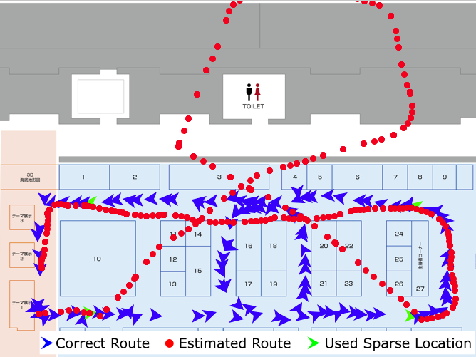

(b) Utilize the model using similarity transformation.

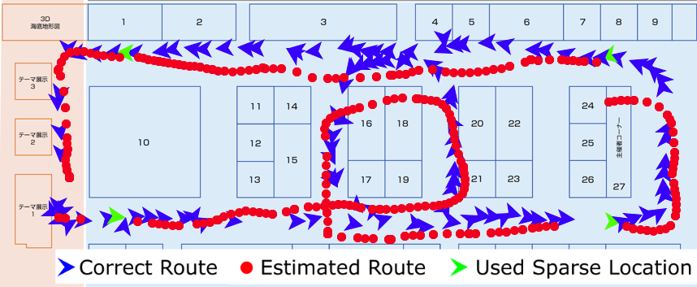

(d) Utilize the model using linear approximation and the unbalanced error model.

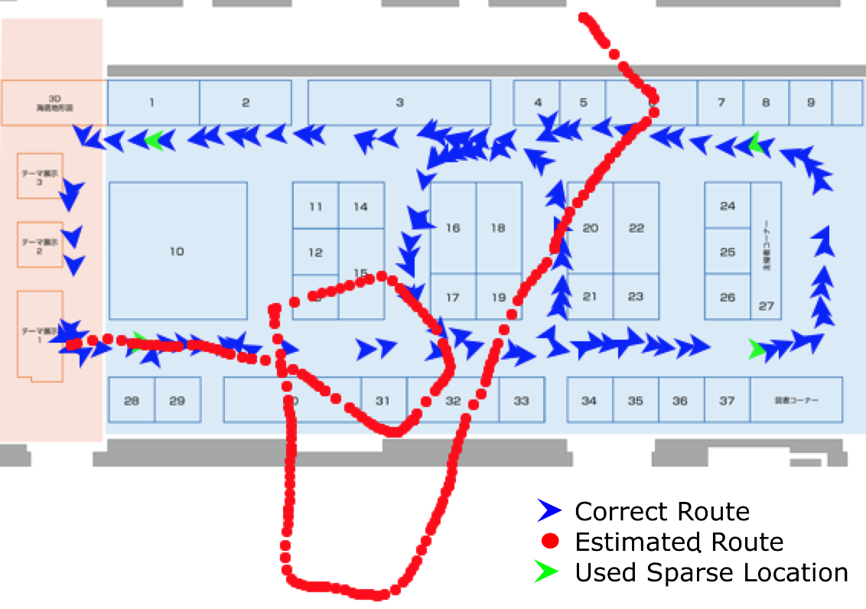

(a) No compensation.

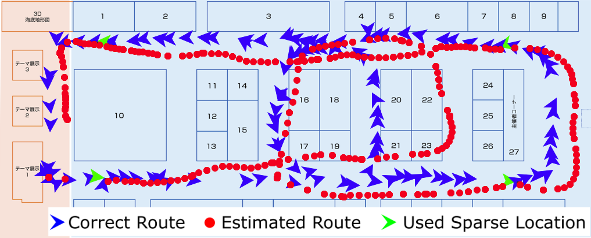

(c) Utilize the model using similarity transformation and the unbalanced error model.

|  |  |
| --- | --- |
| Orientation error model | Error |
| Without Model | 17.66% |
| Model (1) | 7.58% |
| Model (2) | 8.61% |
| Model (3) | 7.06% |

(a) Route B

|  |  |
| --- | --- |
| Orientation error model | Error |
| Without Model | 12.43% |
| Model (1) | 11.44% |
| Model (2) | 8.90% |
| Model (3) | 9.16% |

(b) Route C

Table 8. Position error rates average of individual routes in utilizing the model using linear approximation.

* Improvement of error models

In this research, current error models are linear. A nonlinear model may be designed. Also, we should evaluate the error model that has not been evaluated and improve this.

* Using other devices to obtain sparse locations.

Sparse locations that we are using currently are obtained by UWB localization system. In practice, we should use sparse locations obtained from inexpensive devices, such as BLE. Therefore a scheme considering estimation error of sparse locations is necessary.

# Acknowledgements

Part of this research was supported by the Executive Committee of Geospatial EXPO 2016 indoor localization x IoT demonstration experiment, JSPS KAKENHI Grant Number JP 17H01762.

# References

1. Abe, M., Kaji, K., Hiroi, K., Kawaguchi, N. PIEM: Path Independent Evaluation Metric for Relative Localization, In Proceedings of the Seventh International Conference on Indoor Positioning and Indoor Navigation (IPIN2016), 2016.
2. Ban, R., Kaji, K., Hiroi, K., Kawaguchi, N.: Indoor Positioning Method Integrating Pedestrian Dead Reckoning with Magnetic Field and WiFi Fingerprints, In Proceedings of The Eighth International Conference on Mobile Computing and Ubiquitous Networking (ICMU2015), pp.169-174, 2015.
3. B. Ferris, D. Fox, and N. Lawrence, WiFi-SLAM Using Gaussian Process Latent Variable Models, in Proc. 20th international joint conference on Artifical intelligence, ser. IJCAI, pp. 2480–2485, 2007.
4. Chang Q., Van de Velde S., Wang W., Li Q., Hou H., Heidi S. Wi-Fi Fingerprint Positioning Updated by Pedestrian Dead Reckoning for Mobile Phone Indoor Localization. In Proceedings of China Satellite Navigation Conference (CSNC), Volume III. Lecture Notes in Electrical Engineering, Vol. 342, 2015.
5. Endo, I., Fujita, S., Indoor Tracking Method Using Multiple Sensors in Devices [in Japanese], In Proceedings of The Multimedia, Distributed, Cooperative, and Mobile Symposium (DICOMO), Vol. 2013, pp.188-195, 2013.
6. R. Faragher and R. Harle, Location Fingerprinting With Bluetooth Low Energy Beacons, IEEE journal on Selected Areas in Communications, vol.33, no.11, pp.2418-2428, 2015.
7. Ioroi, S., Suzuki, T., Tanaka, H., Multiple Floor Dead Reckoning using a Smartphone built-in Sensors [in Japanese], In Proceedings of The Multimedia, Distributed, Cooperative, and Mobile Symposium (DICOMO), Vol. 2013, pp.723-735, 2013.
8. Ito, S., WiFi Localization Method Using Gaussian Process Particle Filter [in Japanese], In Proceedings of The Multimedia, Distributed, Cooperative, and Mobile Symposium (DICOMO), Vol. 2011, pp.439-448, 2011.
9. Kaji, K., Kawaguchi, N., An Estimation Method of 3D Pedestrian Trajectory Based on Stability of Sensing Signal [in Japanese], IPSJ Journal, Vol. 57, pp.12-24, 2016.
10. Miyake, T., Arai, I., An Adaptive Step Length Reasoning for Time Periods and Members of a User’s Party [in Japanese], The Special Interest Group Technical Reports of IPSJ, Vol.2013-MBL-65, pp.1-7, 2013.
11. Shin, B., Lee, J.H., Indoor 3D Pedestrian Tracking Algorithm Based on PDR using Smartphone, In Proceedings of the International Conference on Control, Automation and Systems (ICCAS), pp.1442-1445, 2012.
12. Takeshima, C., Kaji, K., Hiroi, K., Kawaguchi, N., Kamiyama, T., Ohta, K., Inamura, H., A Pedestrian Passage Detection Method by Using Spinning Magnets on Corridors. IPSJ Journal, Vol. 58, pp.43-56, 2017.

1. http://g-expo.jp/2016/